Sri Lanka Institute of Information Technology

Lab Submission

05

**IT24102798**

**Sooriyabandara U.R.G.W.K.**

**Probability and Statistics | IT2120**

B.Sc. (Hons) in Information Technology

**Exercise**

1. Import the dataset (’Exercise– Lab 05.txt’) into R and store it in a data frame called ”Delivery Times”.

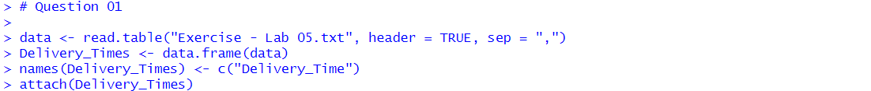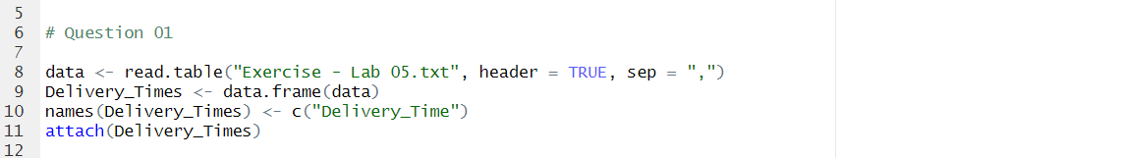

1. Draw a histogram for deliver times using nine class intervals where the lower limit is 20 and upper limit is 70. Use right open intervals.

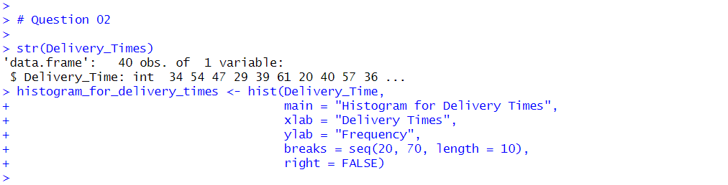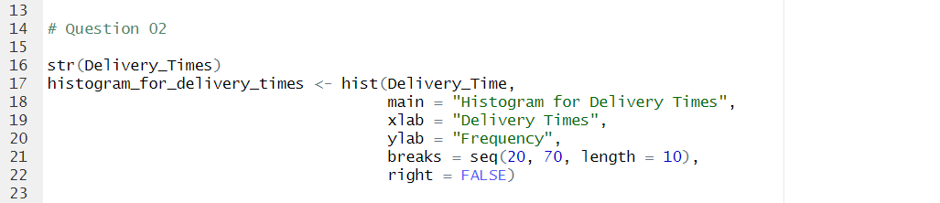

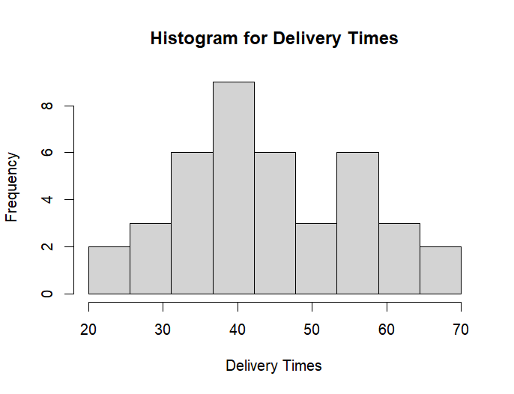

1. Comment on the shape of the distribution.

* The 4th bar has the most frequency, which is 8 while the 1st and 9th bars have the least frequency, which is 2.
* The graph is slightly skewed to the left side.

1. Draw a cumulative frequency polygon (ogive) for the data in a separate plot.



